Adding a Graph to PowerPoint
- Delete the text and the bullet in the box. And select the Insert Graph icon.
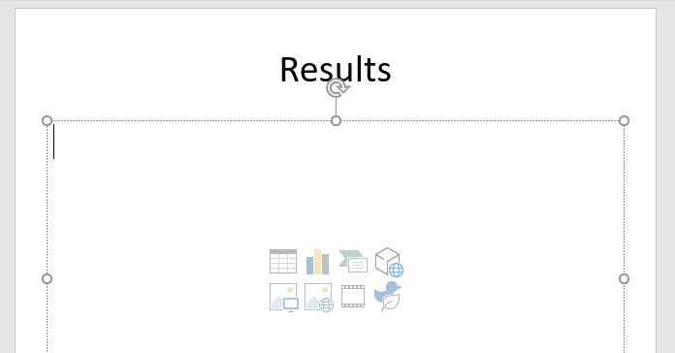
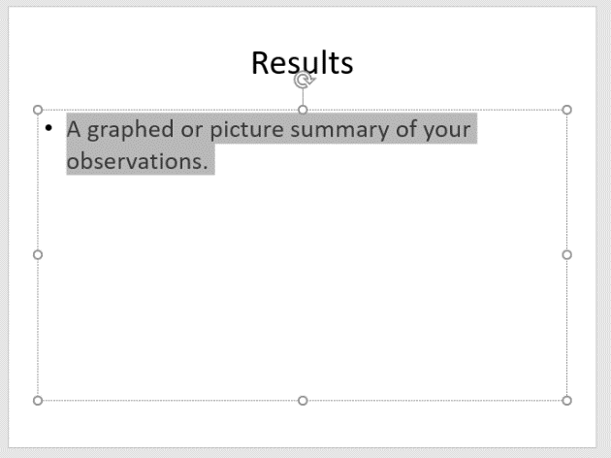

- Select the type of graph that you want and click on OK.
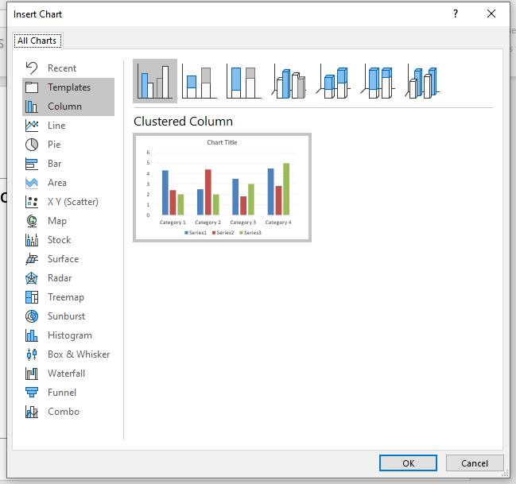

- Change the data inside the EXCEL document at the top of the page to include your data. Use the blue handle at the bottom corner of the graph to reselect the data you want displayed. In this instance we want only the seed numbers we entered shown and we want to add Tomato to the list.

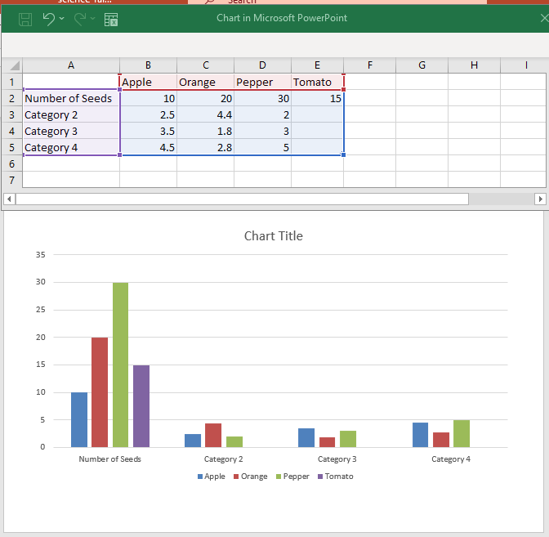

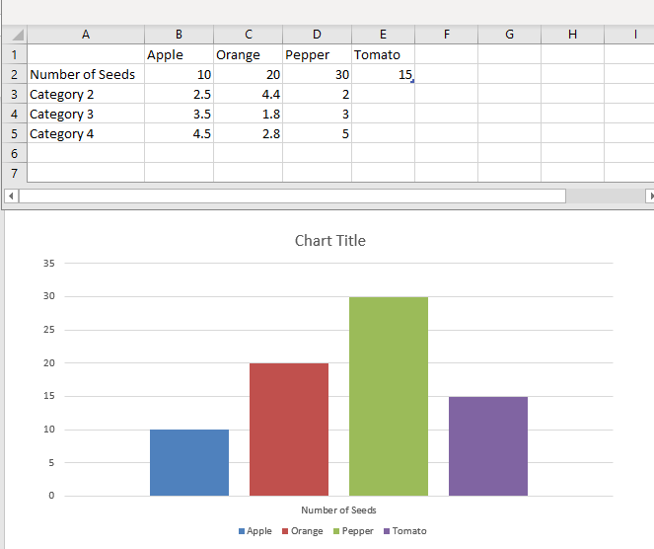
- Delete the data that you do not need and close the Excel Document.
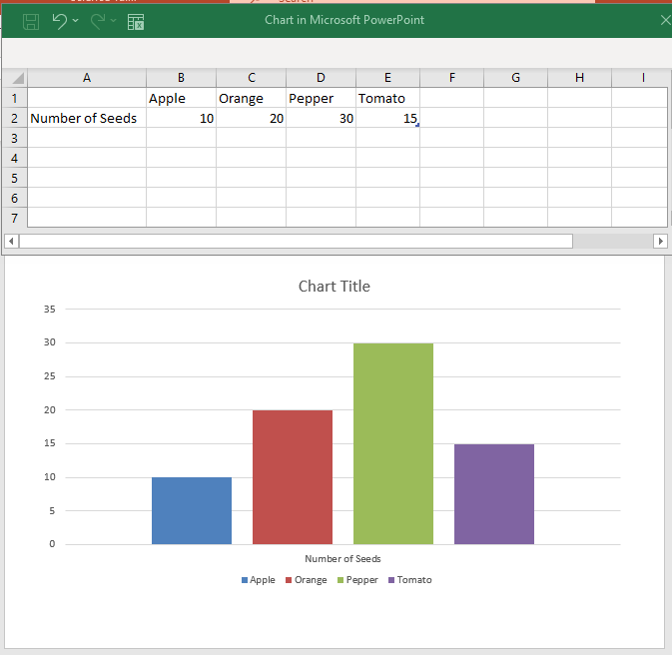

- Click on the graph and go to the CHART DESIGN menu option.
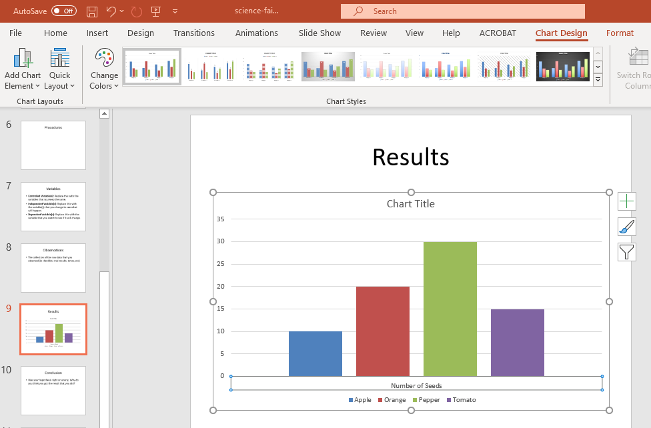

- Click on ADD CHART ELEMENT on the far left of the resulting menu to include things like axis and chart titles, Data Tables, Gridlines, etc.
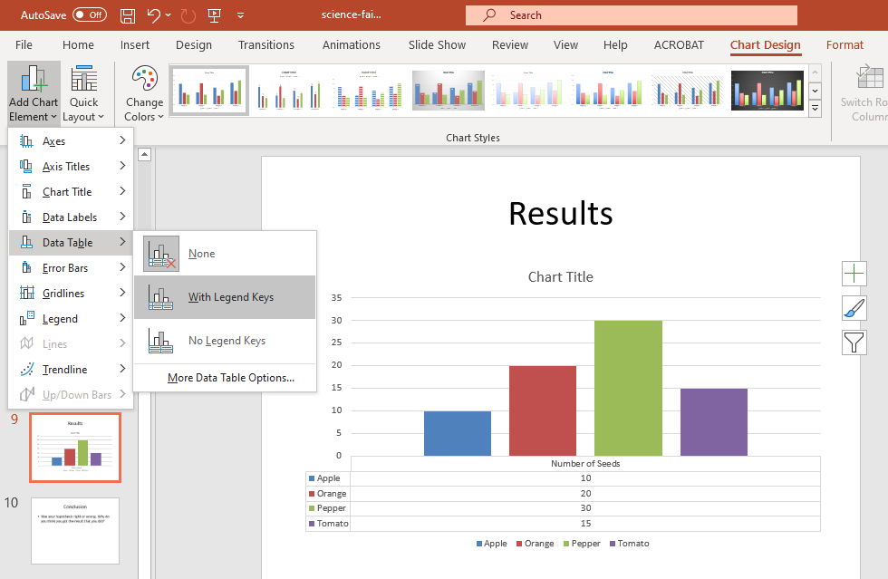

- To change the colour of individual bars, click on the bar, select FORMAT from the far right of the menu, choose SHAPE FILL from the tools and choose a new colour.
